BMI Calculator Project Part 2 Project Output
BMI API UI:
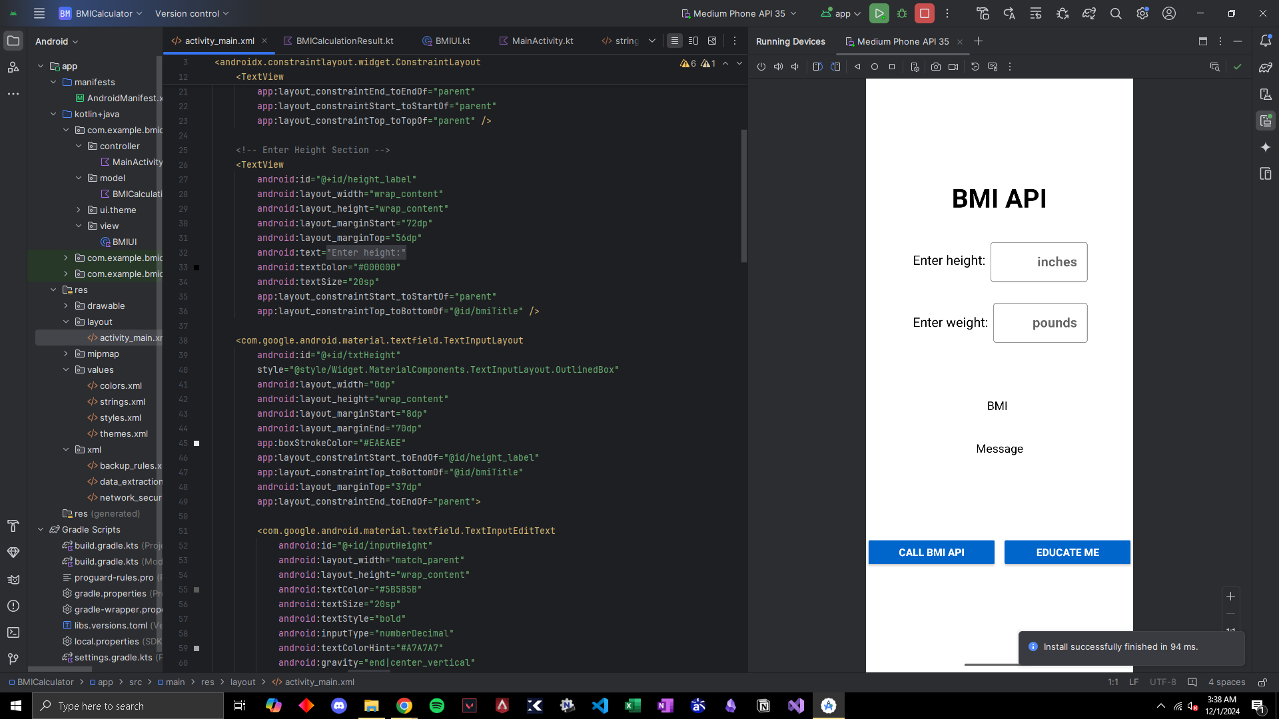
BMI API Normal Output:
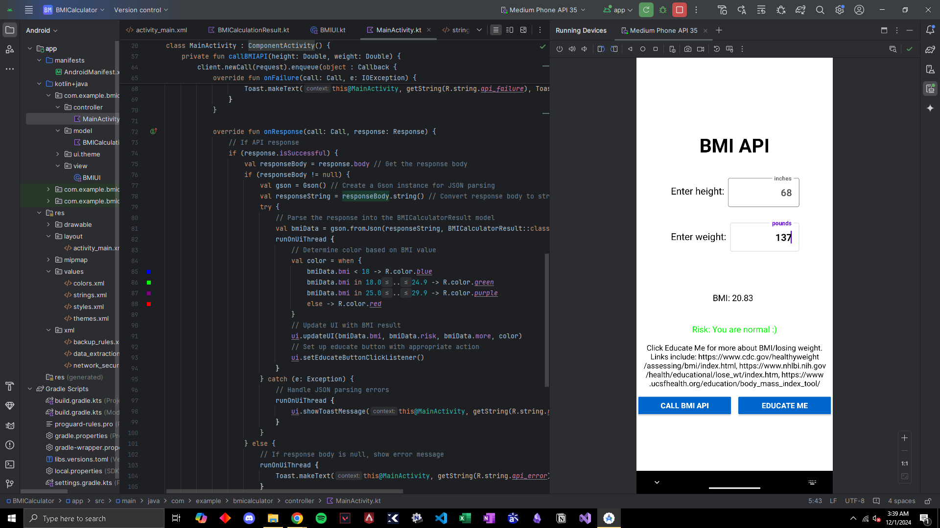

BMI API Educate Me Button Link:
